**Equations in Article**

**Equations in LtSpice**



Figure 1: Article Equations



Figure 2: LT Spice Equations

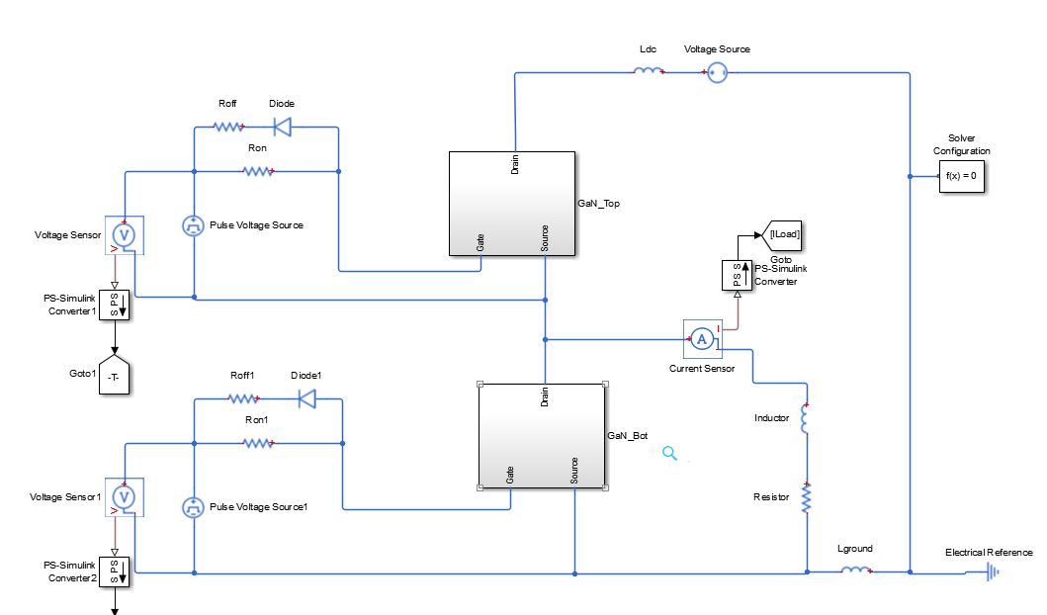

Figure 3: Half Bridge Circuit

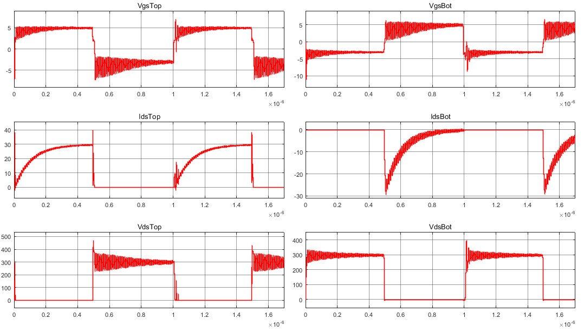

Figure 4: Vgs, Ids, Vds; LEFT -> TOP SW, RIGHT -> BOTTOM SW

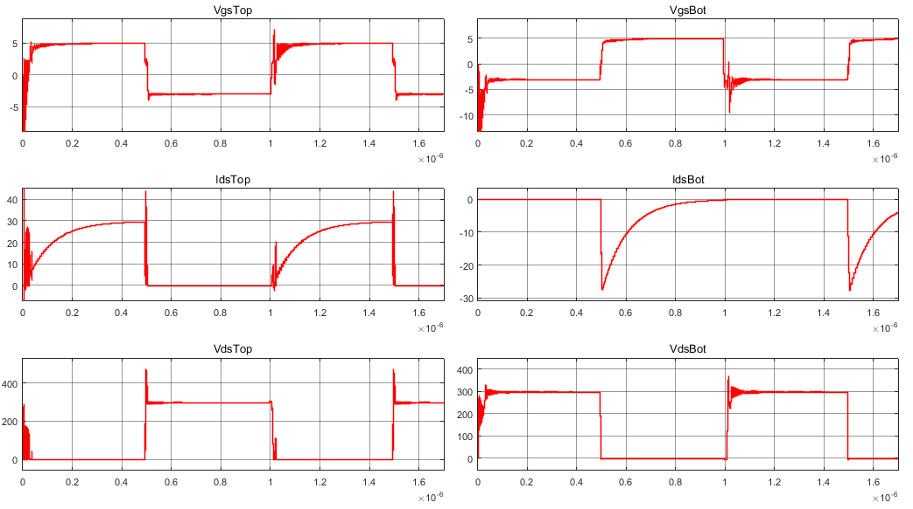

Figure 5: Inductances are eliminated

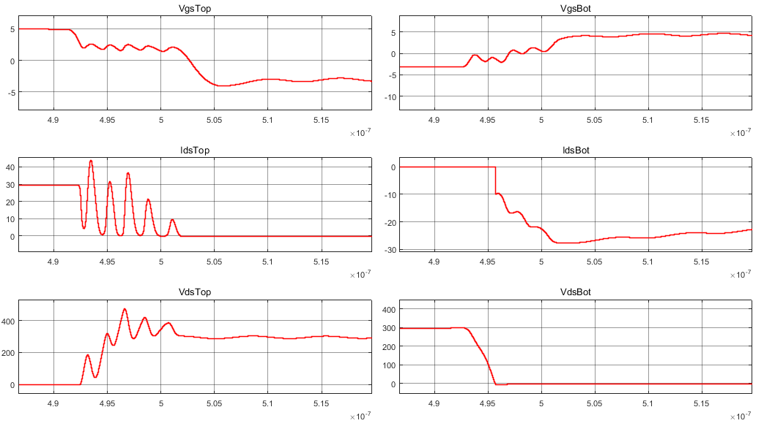

Figure 6: Top Switch Turns OFF, Bottom Switch Turns ON

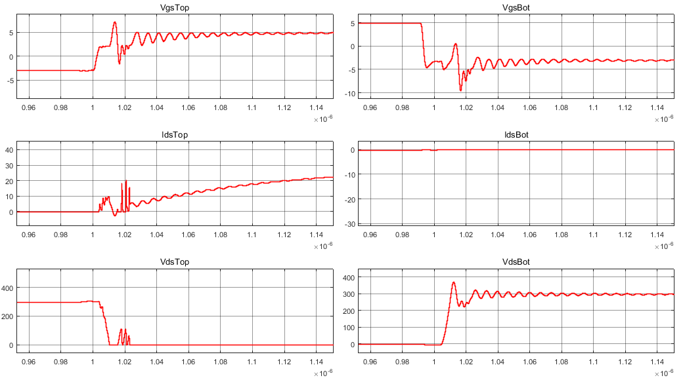

Figure 7: Top Switch Turns ON, Bottom Switch Turns ON